**BTP Report**

**Automated Dataset Generation from PDF files:**

#### **Steps and Methodology:**

**1. Setup and Dependencies:**

* Essential libraries were installed to enable PDF processing, text chunking, embedding generation, and question-answer (QA) modeling.
* The Kaggle environment, equipped with a P100 GPU Accelerator, was utilised for computational efficiency and streamlined processing.

**2. Document Loading and Preprocessing:**

* **PDF Loading:**The PDF file was loaded, and its textual content was extracted for processing. Each page's content was combined into a single text corpus.
* **Text Splitting:**To prepare the data for QA generation, the corpus was divided into manageable chunks using a character-based text splitter. Each chunk maintained a balance between granularity and context retention to ensure meaningful QA pairs could be generated.

**3. QA Pair Generation:**

* **Question Generation Pipeline:**An LLM (Large Language Model) was employed for generating questions from the preprocessed text.
  + **Prompt Engineering:** A carefully crafted prompt guided the LLM to generate diverse and interrogative questions, ensuring relevance to the input text while covering technical details, concepts, and implications.
  + **Iterative Generation:** The process was repeated iteratively across text chunks to generate a comprehensive set of questions. Filtering was applied to ensure unique, well-formed questions.
* **Question Formatting:**Extracted questions were processed to maintain consistency in structure and remove any extraneous information or invalid entries.

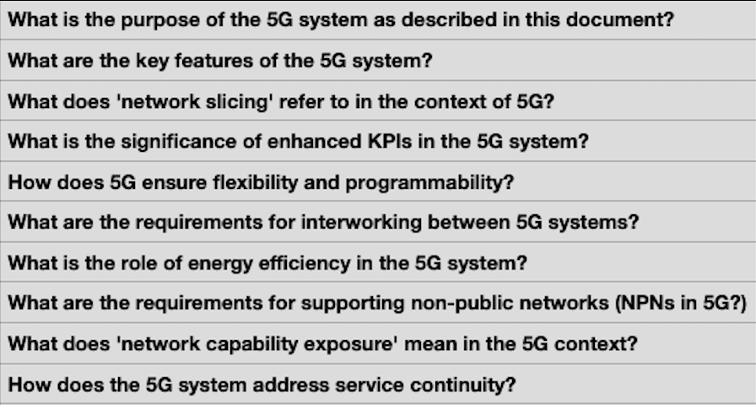

(Snapshot of questions generated from a book “Service requirements for 5G systems: 3GPP TS 22.261”)

**4. Answer Retrieval and Dataset Formation:**

* **Embedding Generation:**Text chunks were embedded into a vector space using a pre-trained embedding model to enable efficient retrieval.
* **Vector Search-Based Answering:**The generated questions were fed into a QA pipeline that retrieved the most relevant text chunks and used the LLM to generate answers.
* **Output Storage:**A CSV file containing two columns—Questions and Answers—was created. This structured dataset ensured easy accessibility for downstream tasks.

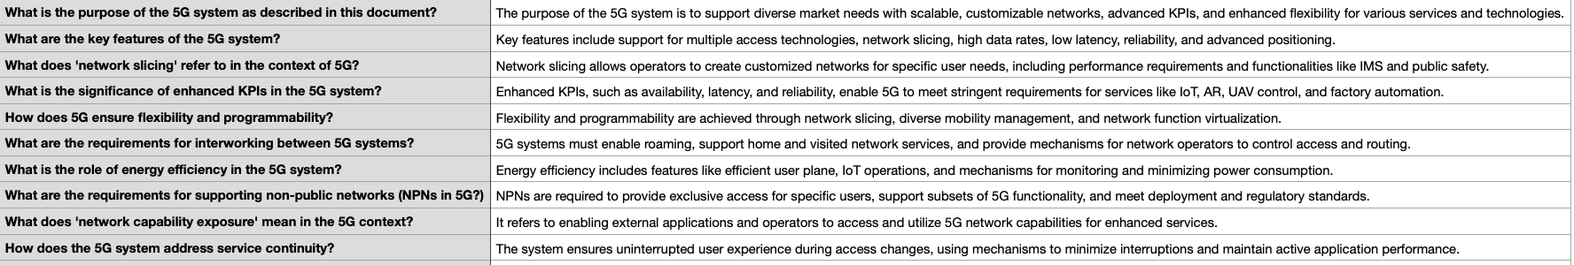

(Snapshot of answers generated for the respective question as above image.)

Examples:

Ex 1: Question: What is the purpose of the 5G system as described in this document?

Answer: The purpose of the 5G system is to support diverse market needs with scalable, customizable networks, advanced KPIs, and enhanced flexibility for various services and technologies.

Ex 2: Question: What is the significance of enhanced KPIs in the 5G system?

Answer: Enhanced KPIs, such as availability, latency, and reliability, enable 5G to meet stringent requirements for services like IoT, AR, UAV control, and factory automation.

### **Libraries Used:**

1. **LangChain**: Central to the document processing, question generation, and retrieval tasks.
2. **CTransformers**: Enables efficient interaction with transformer-based language models, including LLaMA 2.
3. **FAISS**: Provides a scalable and efficient way to store and query document embeddings.
4. **HuggingFace Hub**: Used for embedding generation and facilitating interaction with pre-trained models.
5. **PyPDFLoader**: Ensures reliable text extraction from PDFs.
6. **RecursiveCharacterTextSplitter**: Optimises the splitting of text into chunks for better processing.

### **Conclusion**

This successfully demonstrates the capability to automate dataset creation for question-answering tasks. The pipeline used ensures efficient text processing, accurate question formulation, and contextual answer generation. The resultant dataset is not only structured but also versatile for a wide range of natural language processing tasks.

**Fine-Tuning a Large Language Model (LLM) on Question-Answer Dataset generated from a pdf file:**

#### **Introduction:**

The primary objective of this project is to fine-tune a pretrained Large Language Model (LLM) on a domain-specific Question-Answer dataset. By customising the model's behaviour for our dataset, we aimed to improve its performance in generating accurate and context-aware responses.

#### **Steps and Methodology:**

1. **Setup and Dependencies**
   * The necessary libraries were installed, including modules for model handling (transformers), dataset loading (datasets), parameter-efficient fine-tuning (peft), and mixed-precision computation (bitsandbytes).
   * The Kaggle environment was used to streamline model training and fine-tuning on GPU P100 Accelerator..
2. **Model**
   * **Model Selection:**We used the Llama2-7b-hf model from Meta as our model. It was loaded in 4-bit quantized format using BitsAndBytesConfig, which reduces memory consumption and accelerates computations.
   * **Tokenizer Initialization:**The AutoTokenizer from transformers was initialised to ensure consistent tokenization of the input dataset. Padding tokens were mapped to the model's end-of-sequence token for compatibility.
3. **Dataset**
   * The fine-tuning dataset was a CSV file containing Question and Answer columns. It was loaded using the datasets library.

A prompt template was designed to guide the model during fine-tuning, using a structured format:   
Provide a detailed answer to the following question.

Question: {Question}

### Answer: {Answer}

* + Each dataset entry was preprocessed by applying the prompt template to create a new text-based field for training.

1. **Fine-Tuning Configuration**
   * **Parameter-Efficient Fine-Tuning (QLoRA):**A low-rank adaptation (LoRA) approach was employed to fine-tune the model efficiently. LoRA injected trainable parameters into specific model layers without requiring updates to the entire model.
   * **Target Layer Selection:**Using a custom function, layers suitable for LoRA tuning were identified, avoiding unnecessary layers like the output (lm_head).
   * **Hyperparameters:**Training hyperparameters, such as batch size, gradient accumulation, learning rate, and mixed precision, were configured using TrainingArguments.
2. **Fine-Tuning Process**
   * The fine-tuning process was carried out using the SFTTrainer class from trl, which integrates with transformers to streamline supervised fine-tuning.



(Snapshot of dataset used for fine tuning containing question and answer columns.) can also be found here: <https://drive.google.com/file/d/1YDa5yzLdl0YvLDBYtNV_6F0oJ7cch1GI/view?usp=drive_link>

Examples:   
Ex 1:   
Question: What are the key features of the 5G system?

Answer: Key features include support for multiple access technologies, network slicing, high data rates, low latency, reliability, and advanced positioning.

Ex 2:

Question: What does 'network slicing' refer to in the context of 5G?

Answer: Network slicing allows operators to create customised networks for specific user needs, including performance requirements and functionalities like IMS and public safety.

1. **Evaluation**
   * A separate test dataset was processed into a prompt-based format.
   * The fine-tuned model generated answers for the test questions, which were decoded and stored in a submission CSV file for evaluation.

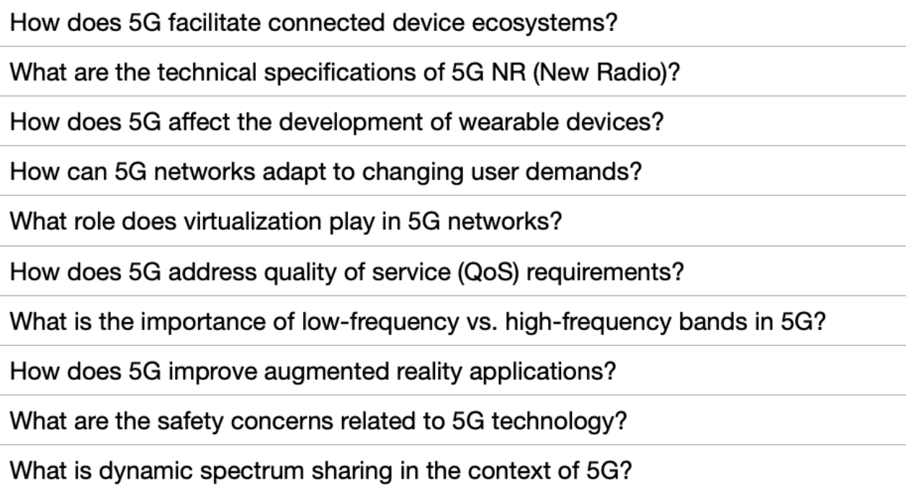  
  
(Snapshot of dataset used for the model evaluation containing only questions.) can also be found here: <https://drive.google.com/file/d/1YOatfUUnWQr_AKIwSUWHLBUoAVVAv01Y/view?usp=drive_link>

Examples:

Ex 1: Question: How does 5G facilitate device ecosystems?

Ex 2: Question: What are the technical specifications of 5G NR (New Radio)?

**Responses before fine tuning:**  
  
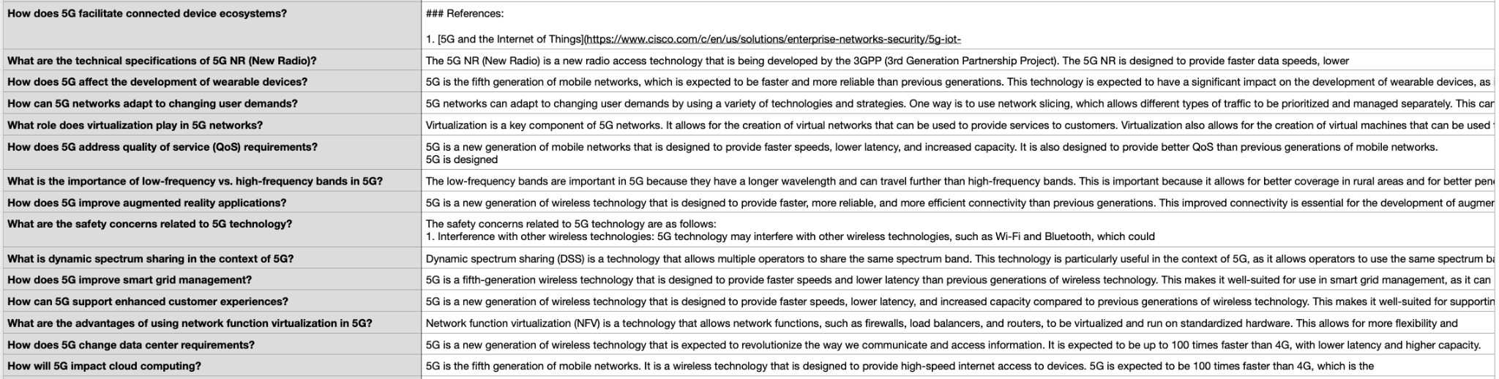

(Snapshot of dataset of answers generated before fine tuning.) can also be found here: <https://drive.google.com/file/d/1NGCosuHZs_LRVR7VHnV_PESku4YGDUfq/view?usp=drive_link>

Ex 1**:** Question: How does 5G facilitate connected device ecosystems?

Answer: ### References: [5G and the Internet of Things](<https://www.cisco.com/c/en/us/solutions/enterprise-networks-security/5g-iot->

Ex 2: Question: What are the technical specifications of 5G NR (New Radio)?

Answer: The 5G NR (New Radio) is a new radio access technology that is being developed by the 3GPP (3rd Generation Partnership Project). The 5G NR is designed to provide faster data speeds, lower.

(Identical answers were observed for some questions prior to fine-tuning, indicating a lack of differentiation.)

1. **Model and Output Storage**
   * The fine-tuned model was saved in the required directory structure and compressed into a ZIP file for portability.

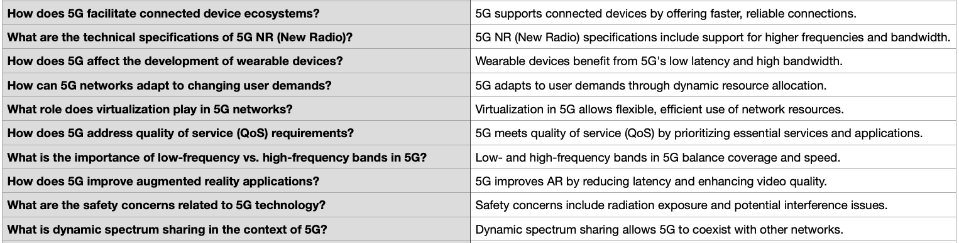

(Snapshot of dataset after model output for the respective for testing dataset above given after fine tuning.) can also be found here:

<https://drive.google.com/file/d/1deEfdn5HbpCoXHCnxv4PchdvALQj9k4x/view?usp=drive_link>

Examples:

Ex 1: How does 5G facilitate connected device ecosystems?

Answer: 5G supports connected devices by offering faster, reliable connections.

Ex 2: What are the technical specifications of 5G NR (New Radio)?

Answer: 5G NR (New Radio) specifications include support for higher frequencies and bandwidth.

#### **Libraries Used:**

* **Transformers:**Central to model handling, it allowed us to load the base model and tokenizer, manage training configurations, and generate responses.
* **Datasets:**Simplified dataset loading, processing, and integration with the training pipeline.
* **PEFT (Parameter-Efficient Fine-Tuning):**Provided LoRA configurations, enabling cost-efficient training without requiring high computational resources.
* **BitsAndBytes:**Facilitated 4-bit quantized loading, reducing memory usage while maintaining computational efficiency.
* **TRL (Transformers Reinforcement Learning):**Powered supervised fine-tuning with dedicated tools like SFTTrainer.
* **Other Utilities:**Libraries such as tqdm, pandas, and warnings enhanced data handling, visualisation, and code robustness.

#### **Conclusion:**

The fine-tuning process successfully tailored the Llama2-7b model to our specific Question-Answer dataset. Using techniques like QLoRA and mixed precision, we minimised resource consumption while achieving effective fine-tuning. The process highlighted the advantages of parameter-efficient techniques, demonstrating how domain-specific customizations can be achieved with limited resources.

The resulting model is well-suited for the intended use case, generating accurate and detailed responses to given questions. This approach can serve as a template for similar domain-specific fine-tuning tasks in the future.

**Fine-Tuning a Large Language Model for Multiple Choice Question Answering:**

### **Introduction:**

Fine-tuning a large language model (LLM) to solve multiple-choice question-answering tasks involves adapting a pre-trained model to a specific dataset and task. The goal of this project was to fine-tune the LLaMA-2 7B model to predict the correct answers from multiple choices (A, B, C, D, E) for a given question. The process utilised efficient fine-tuning methods such as QLoRA to save computational resources and required adapting various tools and libraries for optimal results.

### **Steps Involved:**

#### **1. Dataset**

The dataset consisted of a CSV file containing questions and corresponding options (A, B, C, D, E), with a column indicating the correct answer. A specific text template was designed to structure the input for the model, ensuring uniformity in training. The dataset was processed and formatted using the datasets library for compatibility with the model's input requirements.

Training dataset can be found here: <https://drive.google.com/file/d/1tRQhR3I0_tkVH-RJJ4FGH7finAyhIhfb/view?usp=drive_link>

Ex 1: Question: What is the term used in astrophysics to describe light-matter interactions resulting in energy shifts in the radiation field?

1. Blueshifting
2. Redshifting
3. Reddening
4. Whitening
5. Yellowing

Answer: C

Ex 2: Question: What is the butterfly effect?

1. The butterfly effect is a physical cause that occurs when a massive sphere is caused to roll down a slope starting from a point of unstable equilibrium, and its velocity is assumed to be caused by the force of gravity accelerating it.
2. The butterfly effect is a distributed causality that opens up the opportunity to understand the relationship between necessary and sufficient conditions in classical (Newtonian) physics.
3. The butterfly effect is a proportionality between the cause and the effect of a physical phenomenon in classical (Newtonian) physics.
4. The butterfly effect is a small push that is needed to set a massive sphere into motion when it is caused to roll down a slope starting from a point of unstable equilibrium.
5. The butterfly effect is a phenomenon that highlights the difference between the application of the notion of causality in physics and a more general use of causality as represented by Mackie's INUS conditions.

Answer: E

#### **2. Model Selection**

The LLaMA-2 7B model, pre-trained on a large corpus, was chosen for its robust natural language understanding capabilities. Quantization was applied using the BitsAndBytes library to enable efficient fine-tuning with lower memory usage.

#### **3. Quantization and Configuration**

Quantization was implemented using 4-bit precision with the bnb configuration, allowing faster training with minimal loss in performance. The bnb_4bit_compute_dtype was set to bfloat16 for enhanced numerical stability.

#### **4. Fine-Tuning with QLoRA**

QLoRA (Quantized Low-Rank Adaptation) was applied to fine-tune the model efficiently by adapting only a subset of model parameters. The following steps were involved:

* Identification of target modules in the model for applying QLoRA.
* Specification of parameters like rank (r), dropout, and scaling factor in the LoraConfig.
* Training with the SFTTrainer (Supervised Fine-Tuning Trainer) from the trl library using specified training arguments.

#### **5. Training Arguments**

The fine-tuning process was configured with parameters such as:

* Batch size and gradient accumulation steps for memory efficiency.
* Learning rate and warmup steps for stable optimization.
* FP16 precision for faster computation.
* Logging strategy to monitor training progress.

#### **6. Evaluation**

The model's performance was evaluated by generating predictions for a test dataset. The probabilities of each option (A-E) were computed, and the option with the highest confidence score was selected as the prediction.

Evaluation dataset can be found here: <https://drive.google.com/file/d/1Gdxim-iuH7SfiCrqArnWc_tY0QnpBoR-/view?usp=sharing>

Ex 1: Question: Which of the following is an accurate definition of dynamic scaling in self-similar systems?

1. Dynamic scaling refers to the evolution of self-similar systems, where data obtained from snapshots at fixed times exhibits similarity to the respective data taken from snapshots of any earlier or later time. This similarity is tested by a certain time-dependent stochastic variable x.
2. Dynamic scaling refers to the non-evolution of self-similar systems, where data obtained from snapshots at fixed times is similar to the respective data taken from snapshots of any earlier or later time. This similarity is tested by a certain time-dependent stochastic variable x.
3. Dynamic scaling refers to the evolution of self-similar systems, where data obtained from snapshots at fixed times is dissimilar to the respective data taken from snapshots of any earlier or later time. This dissimilarity is tested by a certain time-independent stochastic variable y.
4. Dynamic scaling refers to the non-evolution of self-similar systems, where data obtained from snapshots at fixed times is dissimilar to the respective data taken from snapshots of any earlier or later time. This dissimilarity is tested by a certain time-independent stochastic variable y.
5. Dynamic scaling refers to the evolution of self-similar systems, where data obtained from snapshots at fixed times is independent of the respective data taken from snapshots of any earlier or later time. This independence is tested by a certain time-dependent stochastic variable z.

Ex 2: Question: Which of the following statements accurately describes the origin and significance of the triskeles symbol?

1. The triskeles symbol was reconstructed as a feminine divine triad by the rulers of Syracuse, and later adopted as an emblem. Its usage may also be related to the Greek name of Sicily, Trinacria, which means "having three headlands." The head of Medusa at the center of the Sicilian triskeles represents the three headlands.
2. The triskeles symbol is a representation of three interlinked spirals, which was adopted as an emblem by the rulers of Syracuse. Its usage in modern flags of Sicily has its origins in the ancient Greek name for the island, Trinacria, which means "Sicily with three corners." The head of Medusa at the center is a representation of the island's rich cultural heritage.
3. The triskeles symbol is a representation of a triple goddess, reconstructed by the rulers of Syracuse, who adopted it as an emblem. Its significance lies in the fact that it represents the Greek name for Sicily, Trinacria, which contains the element "tria," meaning three. The head of Medusa at the center of the Sicilian triskeles represents the three headlands.
4. The triskeles symbol represents three interlocked spiral arms, which became an emblem for the rulers of Syracuse. Its usage in modern flags of Sicily is due to the island's rich cultural heritage, which dates back to ancient times. The head of Medusa at the center represents the lasting influence of Greek mythology on Sicilian culture.
5. The triskeles symbol is a representation of the Greek goddess Hecate, reconstructed by the rulers of Syracuse. Its adoption as an emblem was due to its cultural significance, as it represented the ancient Greek name for Sicily, Trinacria. The head of Medusa at the center of the Sicilian triskeles represents the island's central location in the Mediterranean.

#### **7. Saving the Fine-Tuned Model**

After training, the fine-tuned model was saved in a directory for future use. The model directory was also zipped for easy sharing and deployment.

Submission dataset can be found here: <https://drive.google.com/file/d/1AKLHkID4CjcgfeEllerptexWS0vRY4uW/view?usp=drive_link>

### Ex : Question No, option ( as above).

### A

1. B

### **Libraries Used:**

* **Transformers:** To load the pre-trained model, tokenizer, and implement causal language modeling tasks.
* **BitsAndBytes:** For 4-bit quantization, enabling efficient model loading and training.
* **Peft:** To apply QLoRA for lightweight and memory-efficient fine-tuning.
* **TRL:** For supervised fine-tuning and data collation specific to language models.
* **Datasets:** For loading, processing, and formatting the CSV datasets.
* **LangChain:** For designing and using the prompt template effectively.
* **Pandas & NumPy:** For managing dataset manipulations and numerical computations.

### **Conclusion**

The fine-tuning process successfully adapted the LLaMA-2 7B model for multiple-choice question-answering tasks. By leveraging advanced techniques like QLoRA and using appropriate tools and libraries, the project demonstrated efficient fine-tuning within constrained environments. The resulting model can now generate predictions with high accuracy, making it suitable for applications in educational assessments and automated question-answering systems.  
  
Collection of all the datasets provided above in all the aspects can be found in this drive link: <https://drive.google.com/drive/folders/1-fjmHF4zWUzBtkYzMWy7ZVeGQFB9SB-d>

**By,  
Kethavath Ajay Kumar,  
2021CS11211**